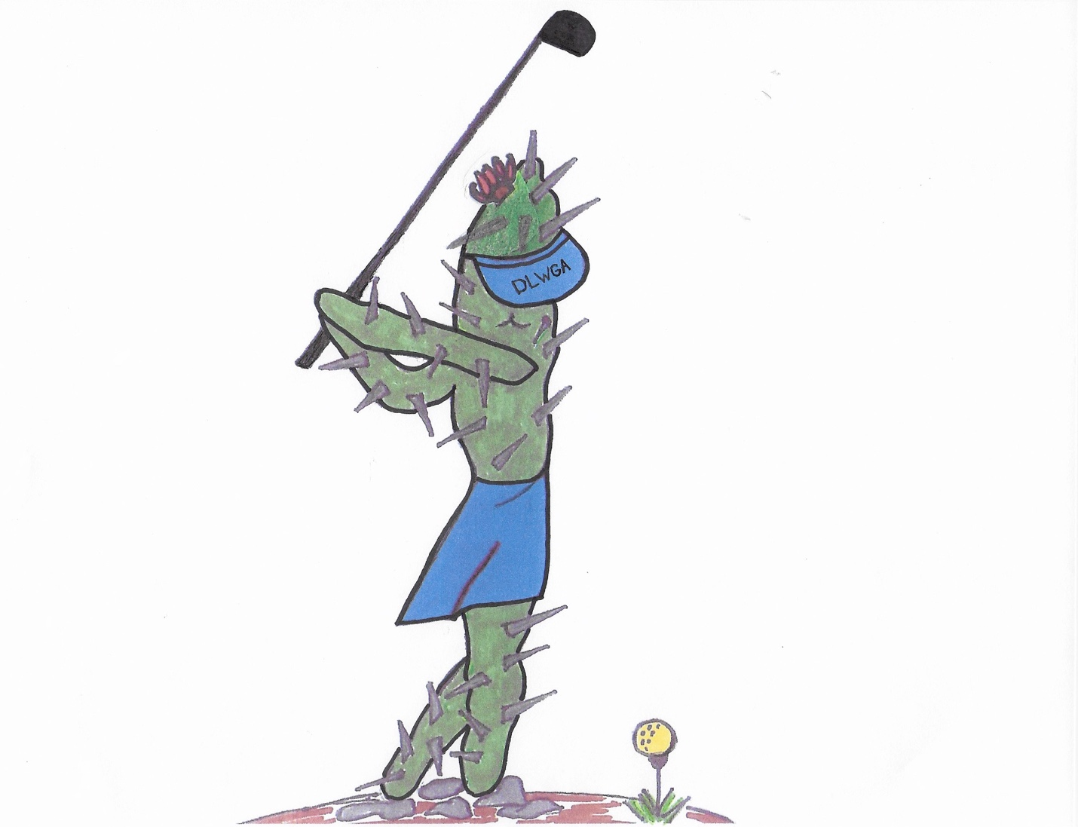
DLWGA Constitution and By-Laws COMING SOON!

